**🐍 Python Tasks (Only for loops, no strings or collections)**

1. **Print numbers from 1 to 20**

Use a for loop to print each number from 1 to 20.

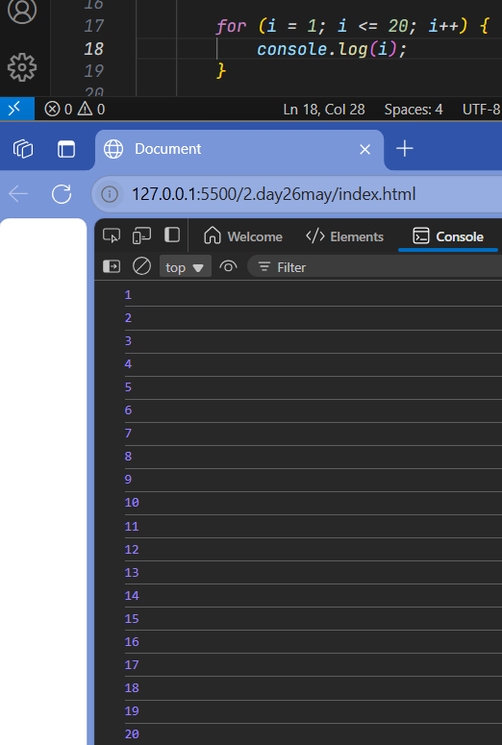

1. **Print the square of numbers from 1 to 10**

Use a for loop to calculate and print i*i for each i.

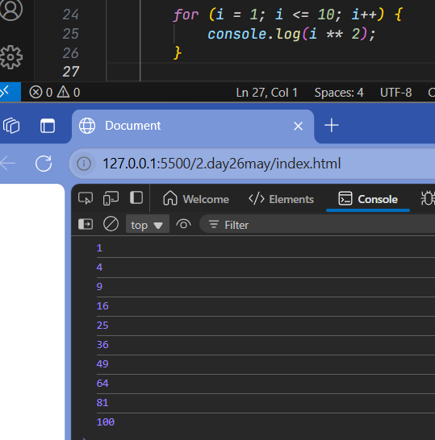

1. **Print the multiplication table of a number (input from user)**

Print from num × 1 to num × 10.

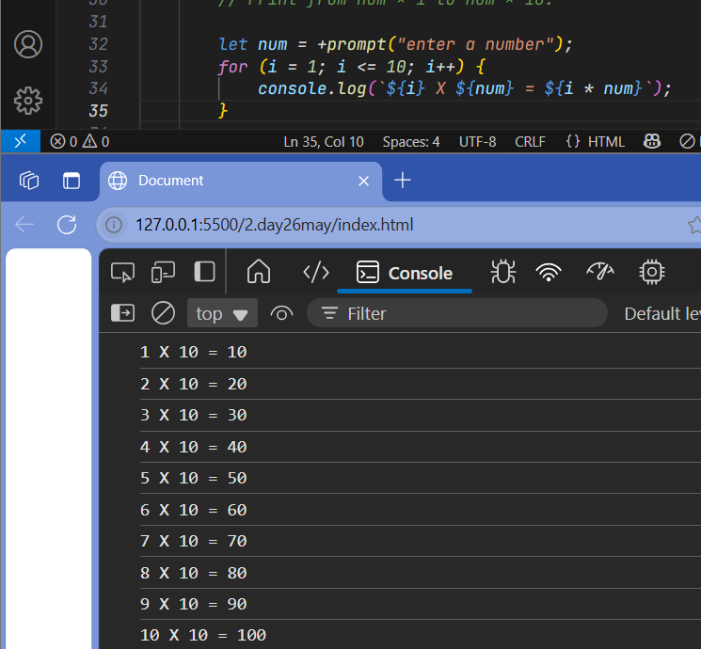

1. **Count how many numbers between 1 and 50 are divisible by 5**

Use a counter variable inside a for loop.

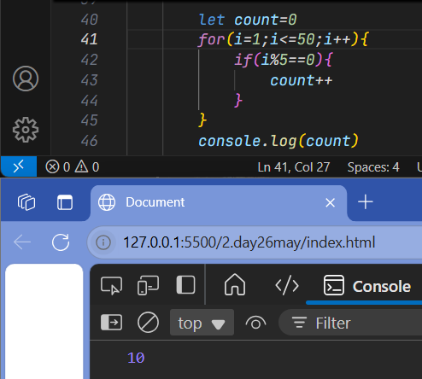

1. **Calculate factorial of a number using a for loop**

E.g., Input: 5 → Output: 120

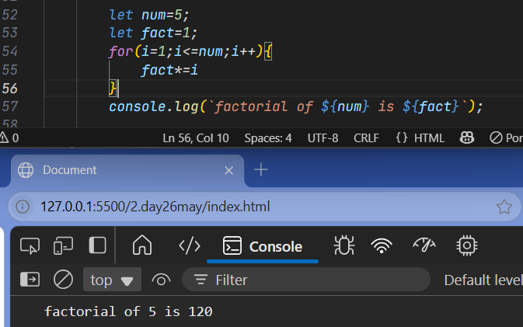

**🌐 JavaScript Tasks**

1. **Create a button that shows an alert when clicked**

Alert message: "Button clicked!"

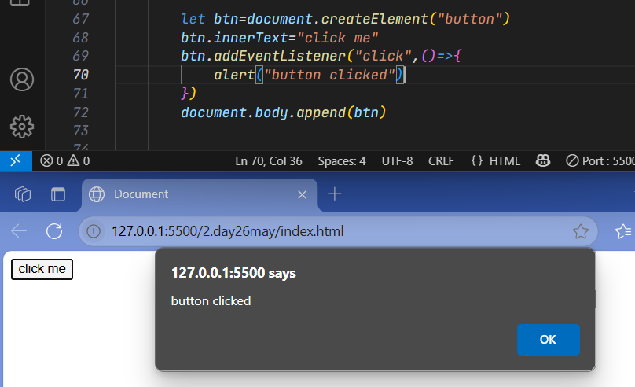

1. **Create a web page that changes background color on button click**

Use document.body.style.backgroundColor.

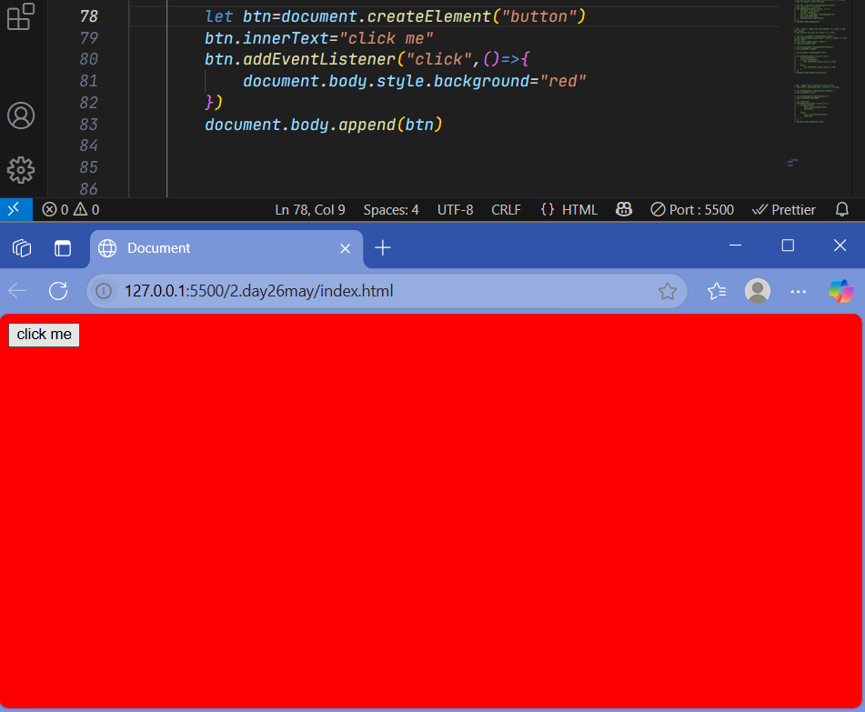

1. **Show current time below a button when it's clicked**

Use new Date() to get the time.

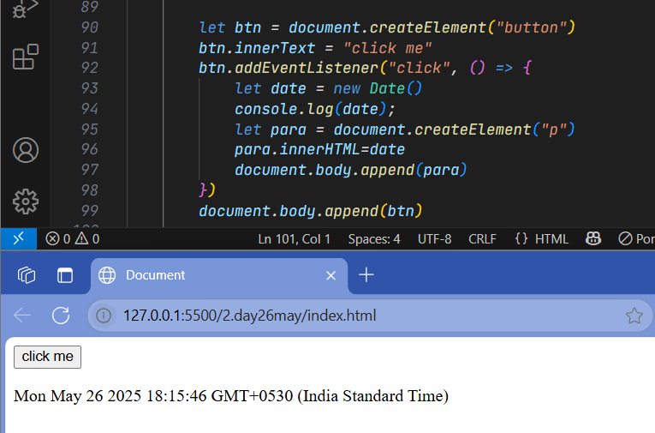

1. **Input a number and show whether it's even or odd (no reload)**

Use onClick and show the result in a <div>.

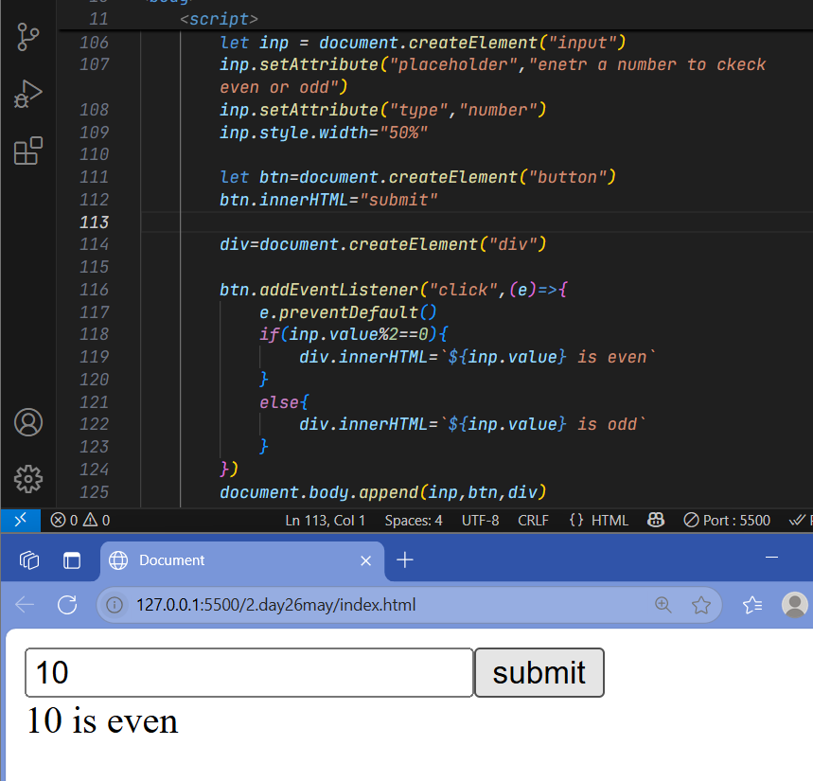

1. **Toggle text visibility with a button**

Show/hide a paragraph when a button is clicked.

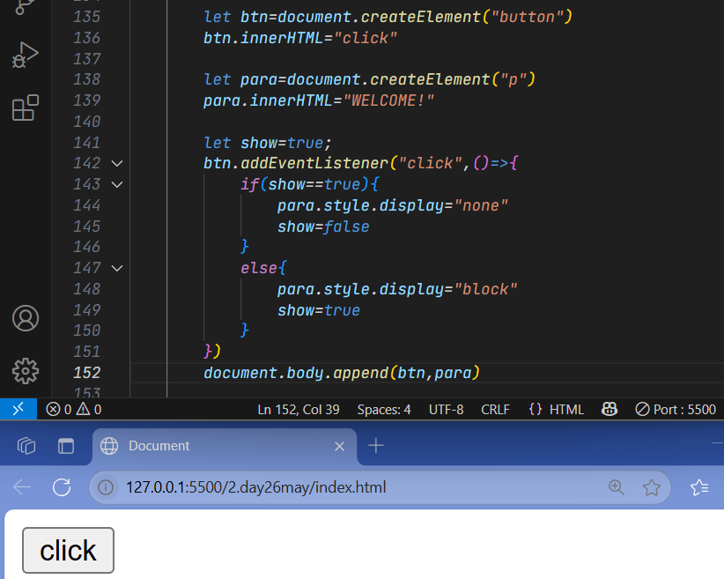

1. **Create a table named students with columns id, name, age**

create table students( id int, name varchar(20), age int);

1. **Insert 3 student records into the students table**

insert into students values(1,"JENNY",23),(2,"ZOE",20),(3,"MARK",18);

1. **Write a query to select all students aged over 18**

select * from students where age>18;

1. **Update a student's name based on their id**

update students set name="ADAM" where id=3;

1. **Delete a student whose id is 3**

**delete from students where id=2;**

